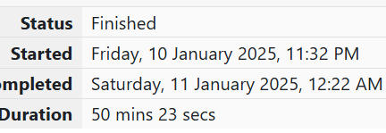

WEEK 6

1.OBJECTIVE

CODE

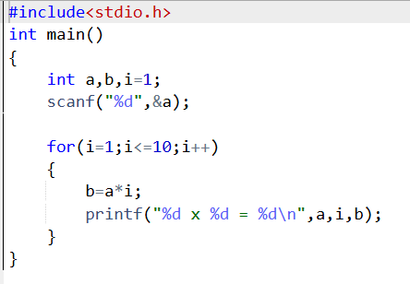

OUTPUT

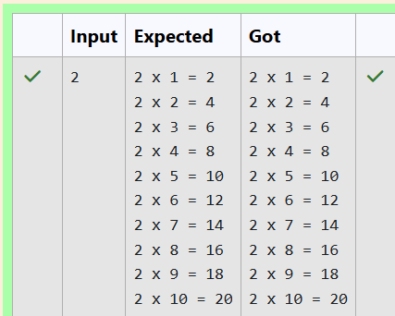

2.OBJECTIVE

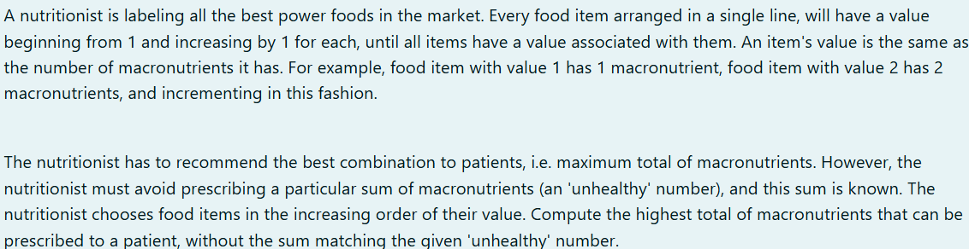

CODE

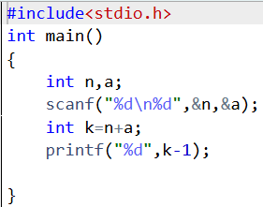

OUTPUT

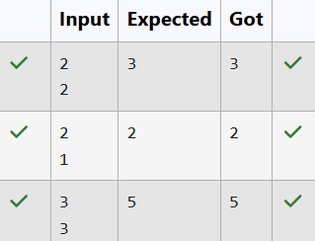

3.OBJECTIVE

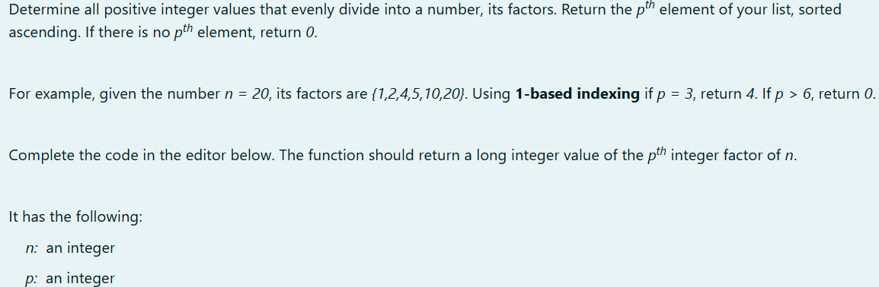

CODE

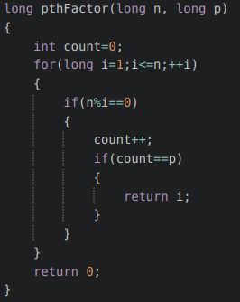

OUTPUT

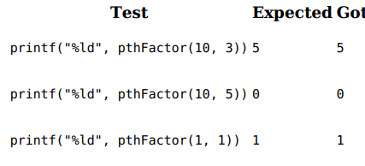

4.OBJECTIVE

Given an array A of sorted integers and another non negative integer k, find if there exists 2 indices i and j such that A[i] - A[j] = k, i != j.

CODE

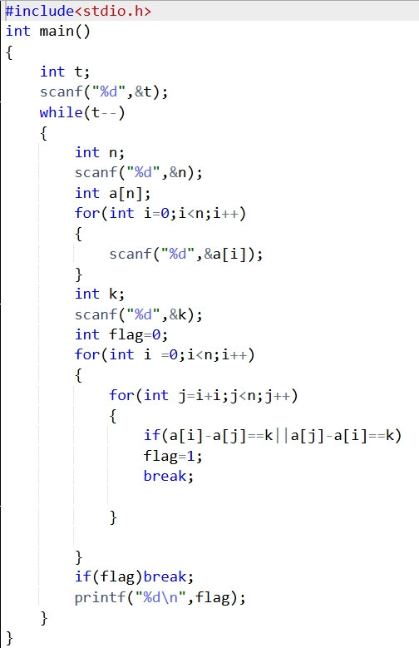

OUTPUT

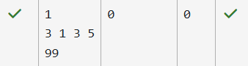

5.OBJECTIVE

Sam loves chocolates and starts buying them on the 1st day of the year. Each day of the year, x, is numbered from 1 to Y. On days when x is odd, Sam will buy x chocolates; on days when x is even, Sam will not purchase any chocolates. Complete the code in the editor so that for each day Ni (where 1 ≤ x ≤ N ≤ Y) in array arr, the number of chocolates Sam purchased (during days 1 through N) is printed on a new line. This is a function-only challenge, so input is handled for you by the locked stub code in the editor.

CODE

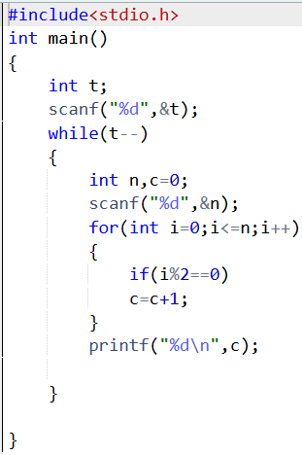

OUTPUT

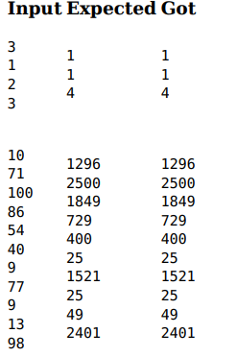

6.OBJECTIVE

The number of goals achieved by two football teams in matches in a league is given in the form of two lists. Consider: • Football team A, has played three matches, and has scored { 1 , 2 , 3 } goals in each match respectively. • Football team B, has played two matches, and has scored { 2, 4 } goals in each match respectively. • Your task is to compute, for each match of team B, the total number of matches of team A, where team A has scored less than or equal to the number of goals scored by team B in that match. • In the above case: • For 2 goals scored by team B in its first match, team A has 2 matches with scores 1 and 2. • For 4 goals scored by team B in its second match, team A has 3 matches with scores 1, 2 and 3. #include int main(){ int t; scanf("%d",&t); while(t--){ int n,c=0; scanf("%d",&n); for(int i=0;i<=n;i++){ if(i%2!=0) c=c+i; }printf("%d\n",c); } } 1 2 3 4 5 6 7 8 9 10 11 12 13 59 Hence, the answer: {2, 3}. Complete the code in the editor below. The program must return an array of m positive integers, one for each maxes[i] representing the total number of elements nums[j] satisfying nums[j] ≤ maxes[i] where 0 ≤ j < n and 0 ≤ i < m, in the given order.

CODE

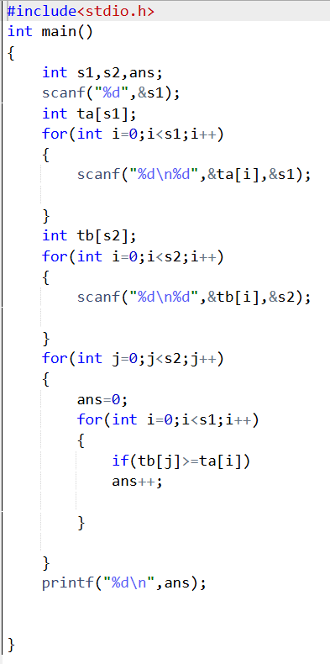

OUTPUT

